**2020 Holiday Meals**

**Christmas Eve**

* Twice Smoked Spiced Apricot Glazed Ham
* Spiced Apricot Glazed Turkey Breast
* Mashed Potatoes
* Vegetable

**Schedule**

* ✓ 11:00 Prepare Breakfast Casserole
* ✓ 12:00 Prepare Mashed Potatoes
* ✓ 1:20 WSM Prep begins (Minion method, 22 hot coals, 225°F Target, Kingsford BB + Applewood)
* ✓ 3:00 Ham on WSM for 30 minute smoke
* ✓ 3:30 Ham Wrapped with Sauce
* ✓ 3:30 Kettle Prep (400°F Goal, Use Jealous Devil)
* ✓ 4:45 Turkey on Kettle
* ✓ 6:00 Glaze 1 (at 130°F Internal), Turkey Glaze
* ✓ 6:10 Glaze 2, Turkey Glaze
* ✓ 6:20 Ham off WSM, Turkey off grill at 158°F
* ✓ 6:30 Ham sear on kettle to set glaze
* ✓ 6:40 Finish Sauce
* ✓ 6:45pm Dinner

**Christmas Morning**

* Breakfast casserole

**Christmas Day**

* Leftovers!

**New Year’s Eve**

* GetMaineLobster.com…overnight delivery 12/30/2020
  + 4 5-6 oz lobster tails
  + 12 stuffed clams
  + 2 lbs Jonah crab claws
  + 1 qt clam chowder
  + 4 whoopie pies

**Twice-smoked Wet-Cured Ham (from Meathead’s book)**

* ~8 lb bone-in spiral sliced ham (cooked)
* 1 cup Spiced Apricot Glaze
* 1 cup chicken broth

1. Prepare the glaze using the recipe below. Double the recipe to have enough for a Turkey too.
2. Combine 5 Tbsp. of the glaze with the chicken broth in a small saucepan to make a mop sauce. Whisk over medium heat until the glaze has dissolved. Can be made ahead and refrigerated.
3. Spritz the ham with water and let some water get into the spiral slices to mitigate moisture loss.
4. Setup the WSM for 225°F, add fruitwood prior to adding the meat, and smoke the ham, cut side down, for 30 minutes.
5. Using 5 to 6’ of heavy duty foil, fold in half, and place the warmed ham in the middle, cut side down. Start bringing the foil upwards to make a bowl and add ½ of the mop sauce and seal it up (like a giant Hershey Kiss. Be careful not to puncture the foil! Place back in the WSM. Add a temperature probe such that the probe is about 1” from the bone and go through the foil high enough that it doesn’t leak.
6. Once the ham hits 130°F open the foil and paint on some glaze and continue roasting with the foil open. Wait 10 minutes and repeat. After the second glazing remove from the heat.
7. Remove the ham from the foil pouch and pour the drippings into a saucepan with the remaining mop sauce.
8. If desired, sizzle the glaze on each side over the hot side of the kettle. This step may add something, but wasn’t necessary: Place the ham on its side over the open flame to sizzle the glaze….do not burn it…it will probably only need 30 to 60 seconds. Then roll the ham to the next side and repeat until the entire ham has been seared. Place the ham on a serving plate flat side down to rest.
9. Serve the ham with the sauce.

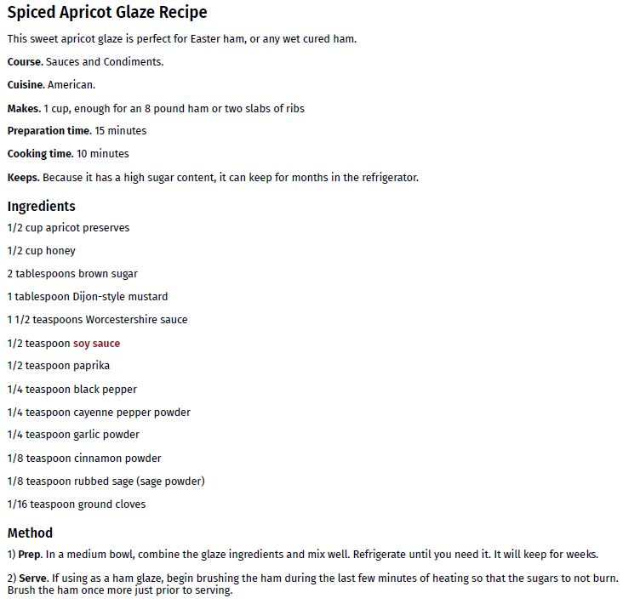

**Purée of Yukon Gold Potatoes with Parmesan**

* 5 pounds Yukon Gold potatoes, peeled, quartered, and rinsed
* 3 teaspoons kosher salt
* 2-1/4 cups whole milk
* 3/4 cup heavy cream
* 3/4 cup unsalted butter
* 1 cup fresh grated Parmigiano Reggiano
* Freshly ground black pepper

1. Put the quartered potatoes in a large saucepan with enough cold water to cover. Partially cover the pot and bring to a boil.
2. Uncover, add the salt, and reduce the heat to a gentle boil. Cook potatoes until tender, 20 minutes. Meanwhile, heat the milk and cream until hot, but do not boil.
3. Drain the potatoes in a colander, let sit for 15 minutes to dry and finish cooking.
4. Use a potato ricer, masher, or food mill to mash the potatoes.
5. Blend the butter, and Parmigiano into the potatoes. Gradually add the milk mixture until the purée is as soft and moist as you like.
6. Add salt and pepper to taste.
7. Keep warm in Crock-pot or similar. I typically simply put the pot of potatoes in boiling water.

**Sausage & Egg Brunch**

* 7 slices white bread
* 1 lb. breakfast sausage
* 2 cups shredded cheddar cheese
* 2 ½ cups whole milk
* 6 eggs
* ¾ Tbsp. dry mustard
* 1 can cream of mushroom soup
* ½ cup whole milk

1. Cube bread and add to a greased 13x9 glass dish
2. Brown sausage and scatter over bread
3. Sprinkle cheese over bread and sausage
4. Beat together milk, eggs, and dry mustard. Pour over bread, sausage, and cheese and let stand overnight.
5. Mix mushroom soup and additional milk and pour over mixture prior to baking
6. Bake at 325°F for 1 hour

**Christmas Toffee**

* 2 sticks of butter
* 1 cup sugar
* 1 Tbsp. water
* 1 Tbsp. light Karo syrup
* 1 cup blanched slivered almonds
* 6 oz package milk chocolate chips

1. Over medium-low heat, melt the butter and add sugar, water, and syrup, heating slowly. Stir constantly for 10 minutes or more until the mixture turns butterscotch colored. Add the almonds.
2. Pour onto parchment paper on a cookie sheet or the counter. Spread the mixture. Top with chips and spread as they melt.
3. Cool completely and break into pieces.

**Links**

Hazlenut Linzer Tarts:

<https://www.seriouseats.com/recipes/2011/12/linzer-cookies-hazelnut-jam-recipe.html>

Green Beans Almondine:

<https://www.abeautifulplate.com/green-beans-almondine/>

**Notes**

* 2020: Niman Ranch ½ spiral ham, 8.09 pounds, $6/lb. The recipe above was updated with the procedure I followed. The ham was fantastic. Leftovers were fantastic. The sauce was fantastic. Gotta call this one a 9 out of 10. The only issue was it cooked about an hour faster than expected, which really isn’t a major issue but was a nuisance as the turkey was cooking slower than expected. The sauce adds a lot…great cold on a sandwich or warmed over leftovers. The turkey was a boneless breast that was wrapped in a mesh bag. It was a large cylinder shape…about 7 pounds. It cooked slower than expected…I should have (1) dry brined it, and (2) removed it from the mesh back so the breasts would lay flat on the grill for faster roasting. I glazed the turkey with the same glaze used on the ham and made a sauce with 1 cup chicken broth and 5 T of glaze. The sauce was very good and was very flavorful. The ham sauce was richer as it had the ham drippings, but the turkey version was yummy as well.